Gregory Romo
MGIS 4360
2/12/25
CP - Feb 12 (Check Flights Staging Data)
- Mandatory constrain:
SELECT *
FROM flight_data
WHERE YEAR = ''
OR MONTH = ''
OR DAY = ''
OR DAY_OF_WEEK = ''
OR AIRLINE = ''
OR FLIGHT_NUMBER = ''
OR ORIGIN_AIRPORT = ''
OR DESTINATION_AIRPORT = ''
OR SCHEDULED_DEPARTURE = ''
OR DISTANCE = ''
OR SCHEDULED_ARRIVAL = ''
OR DIVERTED = ''
OR CANCELLED = '';
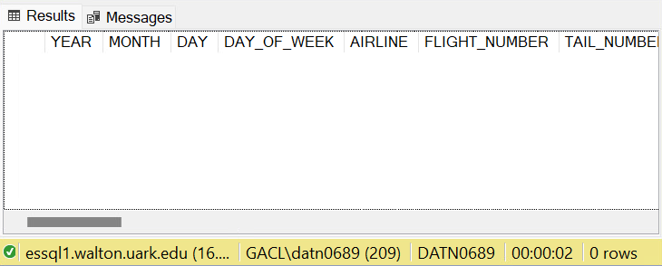

There appear to be zero rows that are empty.

- Airline Foreign-key constraint:
SELECT f.AIRLINE
FROM DS.FlightsStaging f
LEFT JOIN DS.AirlinesStaging a ON f.AIRLINE = a.IATA_CODE
WHERE a.IATA_CODE IS NULL;
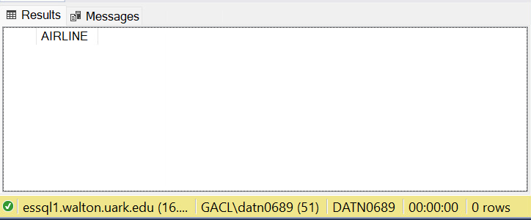
There are no airline codes in FlightStaging without corresponding IATA values in the AirportsStaging.
- Origin Airport Foreign-key constraint:
SELECT count(ORIGIN_AIRPORT) AS "Count"
FROM DS.FlightsStaging f
LEFT JOIN DS.AirportStaging a ON f.ORIGIN_AIRPORT = a.IATA_CODE
WHERE a.IATA_CODE IS NULL;
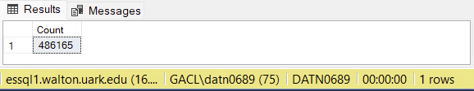
There are multiple(5,819,019) rows that do not a corresponding IATA values in AirportsStaging.

- Destination Airport Foreign-key constraint:
SELECT count(f.DESTINATION_AIRPORT) AS "Count"
FROM DS.FlightsStaging f
LEFT JOIN DS.AirportStaging a ON f.DESTINATION_AIRPORT = a.IATA_CODE
WHERE a.IATA_CODE IS NULL;
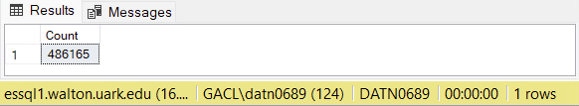
Like the Origin Airport Foreign-key constraint, there are multiple(5,819,019) rows that do not have corresponding IATA values in AirportsStaging.

- Data type for ORIGIN_AIRPORT and DESTINATION_AIRPORT:
SELECT DISTINCT ORIGIN_AIRPORT
FROM DS.FlightsStaging
WHERE LEN(ORIGIN_AIRPORT) <> 3;

SELECT DISTINCT DESTINATION_AIRPORT
FROM DS.FlightsStaging
WHERE LEN(DESTINATION_AIRPORT) <> 3;
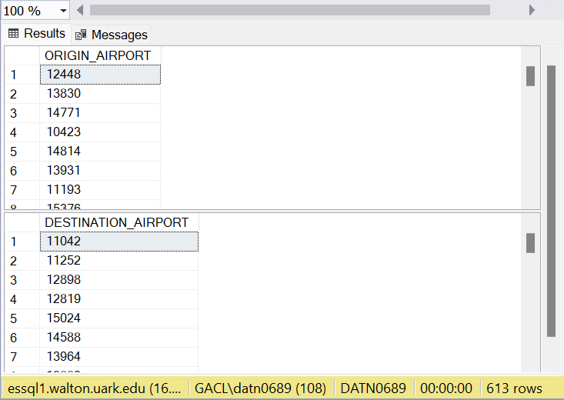
There are 306 ORIGIN_AIRPORT and 307 DESTINATION_AIRPORT values with the wrong length.

- Range constraint for YEAR, MONTH, Day and DAY_OF_WEEK:
SELECT *
FROM DS.FlightsStaging
WHERE YEAR < 2015 OR YEAR > 2015
OR MONTH < 1 OR MONTH > 12
OR DAY < 1 OR DAY > 31
OR DAY_OF_WEEK < 1 OR DAY_OF_WEEK > 7;
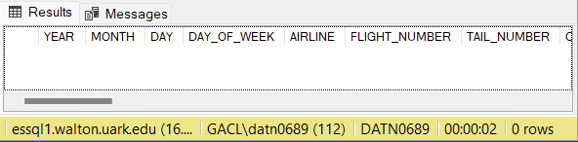
There are no values outside the range constrain.

- Data type for clock times:
SELECT
MIN(LEN(SCHEDULED_DEPARTURE)) AS MinLen_SchedDep, MAX(LEN(SCHEDULED_DEPARTURE)) AS MaxLen_SchedDep,
MIN(LEN(DEPARTURE_TIME)) AS MinLen_DepTime, MAX(LEN(DEPARTURE_TIME)) AS MaxLen_DepTime,
MIN(LEN(WHEELS_OFF)) AS MinLen_WheelsOff, MAX(LEN(WHEELS_OFF)) AS MaxLen_WheelsOff,
MIN(LEN(WHEELS_ON)) AS MinLen_WheelsOn, MAX(LEN(WHEELS_ON)) AS MaxLen_WheelsOn,
MIN(LEN(SCHEDULED_ARRIVAL)) AS MinLen_SchedArr, MAX(LEN(SCHEDULED_ARRIVAL)) AS MaxLen_SchedArr,
MIN(LEN(ARRIVAL_TIME)) AS MinLen_ArrTime, MAX(LEN(ARRIVAL_TIME)) AS MaxLen_ArrTime
FROM DS.FlightsStaging;
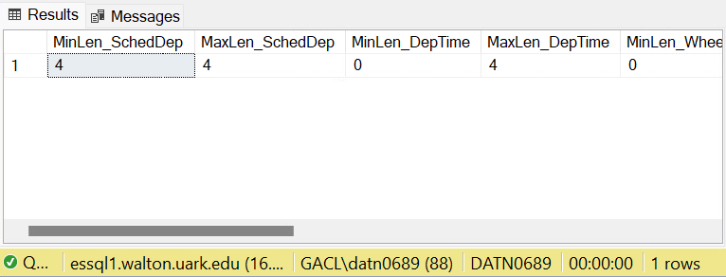

SCHEDULED_DEPARTURE = min 4 and max 4
DEPARTURE_TIME = min 0 and max 4
WHEELS_OFF = min 0 and max 4
WHEELS_ON = min 0 and max 4
SCHEDULED_ARRIVAL = min 4 and max 4
ARRIVAL_TIME = min 0 and max 4

- Range constraints for clock times:
SELECT *
FROM DS.FlightsStaging
WHERE CANCELLED = 0
AND DIVERTED = 0
AND((SCHEDULED_DEPARTURE < '0000' OR SCHEDULED_DEPARTURE > '2400')
OR (DEPARTURE_TIME < '0000' OR DEPARTURE_TIME > '2400')
OR (WHEELS_OFF < '0000' OR WHEELS_OFF > '2400')
OR (WHEELS_ON < '0000' OR WHEELS_ON > '2400')
OR (SCHEDULED_ARRIVAL < '0000' OR SCHEDULED_ARRIVAL > '2400')
OR (ARRIVAL_TIME < '0000' OR ARRIVAL_TIME > '2400')
);
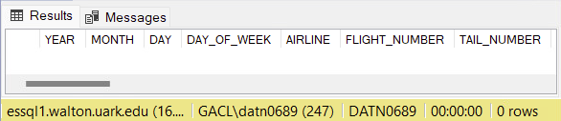
There are no values that appear to be outside the range constrain
- Range constraints for Diverted/Cancelled columns:
SELECT
MIN(DIVERTED) AS Min_Diverted, MAX(DIVERTED) AS Max_Diverted,
MIN(CANCELLED) AS Min_Cancelled, MAX(CANCELLED) AS Max_Cancelled
FROM DS.FlightsStaging;

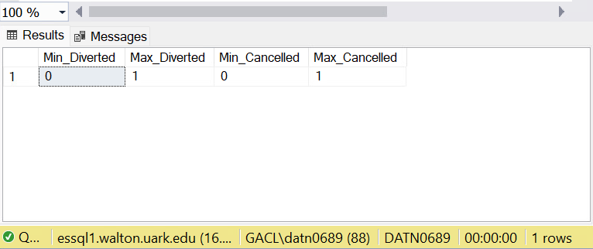
All data has to be 0 or 1 if it is more than that it would be consider outside the range.

